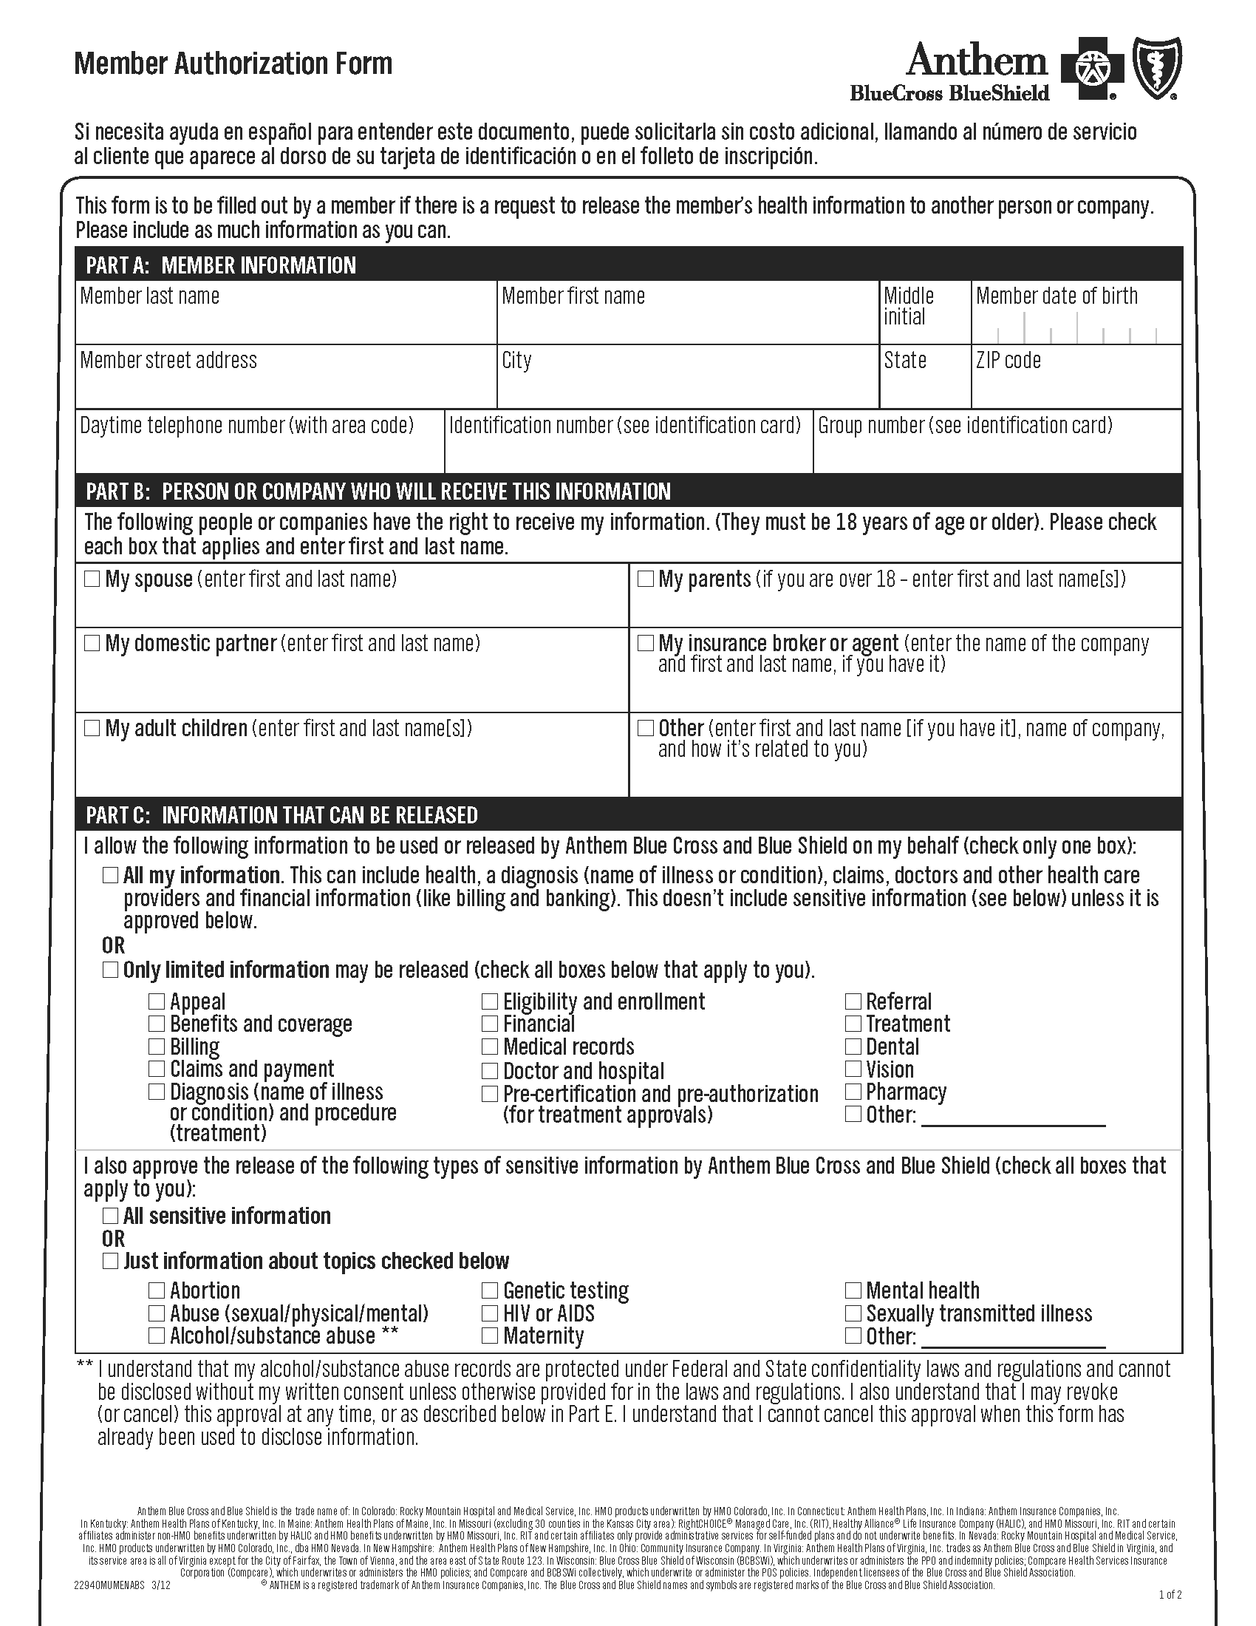
Batman
01/01/1979
X
Axiom Requisition Copy Service - Litigation
X
X

Order No. 01-29018-002
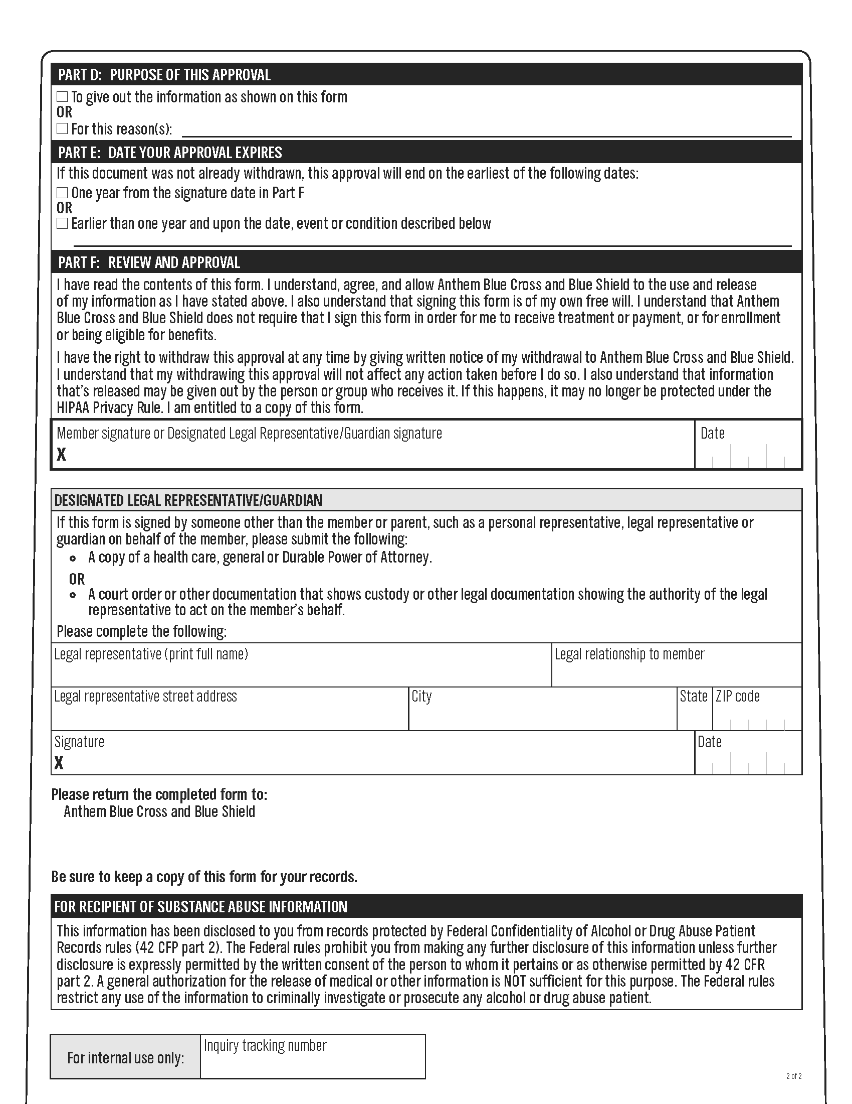
X
Litigation
X
End of Litigation
Order No. 01-29018-002

